An optimal placement and angling of photodiodes is required to produce proper data for attitude determination of the CubeSat.

A MATLAB program was written in order to simulate coverage with given number of photodiodes, their facing vectors, and their effective field of view. The angles were then continuously tweaked in order to find the angles that provide the most optimal coverage of the area surrounding the CubeSat.

The photodiode we are simulating is the TEMD6010FX01, which has an angle of half sensitivity of ~60 degrees. Beyond this point, the current output starts to divert from the expected output from the cosine law, relating output current to light intensity and angle of incidence.

There are 4 photodiodes placed on each solar panel: 2 on the bottom and 2 on the top. There is also an additional 3 photodiodes each on the ±Z end-plates. Only the photodiodes on the solar panels are intended to be angled.

Performing the simulation with various angles, virtually all realistic configurations produced 100% coverage with at least 3 photodiodes. However, sufficient coverage would require being in the view of at least 4 photodiodes (in the case that an antenna casts a shadow on one), which maxes out at around ~70%. Assuming a slightly larger angle of half sensitivity than we have (e.g. > 75 degrees) will produce a near 100% coverage with at least 4 photodiodes, and such a small increase in the FOV will not diverge from the cosine law a significant amount.

An optimal and simple configuration of 30 degrees towards the photodiodes respective end of the Z-axis, and 30 degrees rotated about the solar panel normal towards the photodiode’s closest adjacent solar panel.

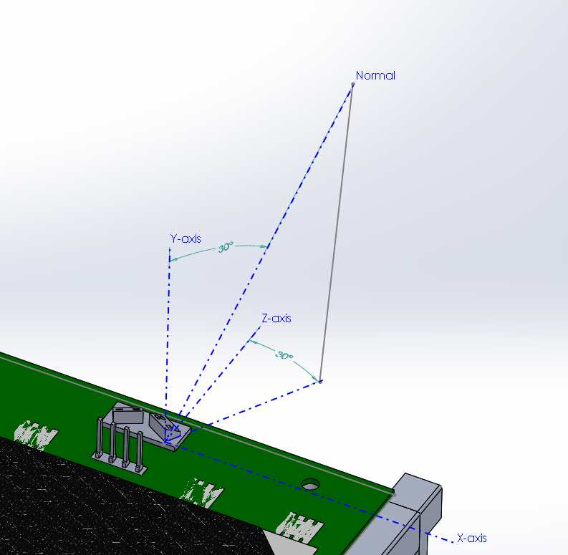

Figure 18, Photodiode mount normal vector angles

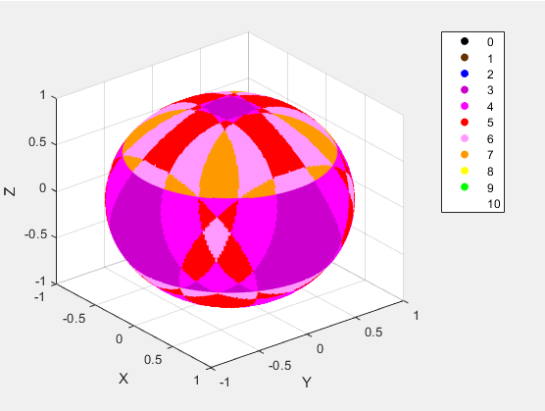

Figure 17, MATLAB simulation, 100% area coverage with >= 3 photodiodes, 70% with >= 4